National Workforce Programme

Presenting problems/disorders local data collection tool for case mix/skill mix data module (for use in Part 3 of the workforce planning template)

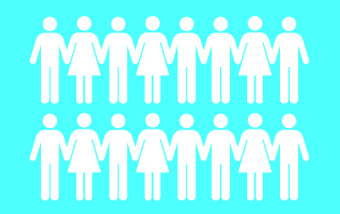

Enter the presenting problems/disorder of all cases worked with during the sample period. In recognition of high levels of co-morbidity in children and young people referred to specialist CAMHS teams, you may record more than one presenting disorder or problem for each case.

Please note
- If more than one member of the team is working with a case, the case should only be counted once.
- That the question refers to the presenting problems at assessment.
 | Number of cases | Normally accepted *
Hyperkinetic disorders / problems 1
Emotional disorders / problems 2
Conduct disorders / problems 3
Eating disorders / problems 4
Psychotic disorders / problems 5
Deliberate self harm 6
Substance abuse 7
Habit disorders / problems 8
Autistic spectrum disorders / problems
Developmental disorders / problems 9
Other
Total

- Includes ADHD and other attention disorders
- Includes anxiety, depression, phobias, obsessional compulsive disorder, post traumatic stress disorder
- Includes anti social behaviour, stealing, defiance, fire-setting and aggression
- Includes pre school eating problems, anorexia nervosa and bulimic nervosa
- Includes schizophrenia, manic depressive disorder or drug-induced psychosis
- Includes lacerations and drug and alcohol overdose
- Refers to drug and alcohol misuse
- Includes tics, sleeping problems and soiling
- Refers to delay in acquiring certain skills such as speech, bladder control and social ability
*Place an X against any types of disorder you would not normally accept for treatment.

